**MAJOR PROJECT REPORT**

ON

**Landing Gear Stress Analysis**

**Submitted By**

**Shashank Yash 1801227471**

|  |  |
| --- | --- |
| **Mahesh Prajapati** | **1801227749** |
| **Sumit Kumar** | **1801227562** |
| **Shantanu Srivastava** | **1801227467** |
| **Navneet Arya** | **1801227295** |
| **Royal Kumar Patel** | **1801227410** |
| **Udaya nath Gour** | **1801227605** |

**………**

**Under The supervision of**

**Dr. B. K. Khamari and Dr. Rahul Kumar**

 **Assistant Professor, Department of Mechanical Engineering**

**Department OF Mechanical Engineering**

**C. V. Raman Global University, Bhubaneswar 2022**

**DECLARATION**

This is to declare that the work in the Major Project Stage-3 entitled “**Landing Gear Stress Analysis**” submitted by **Group number-15** students whose name are as follow**:- Mahesh Prajapati (1801227749), Sumit Kumar (1801227562),Navneet Arya (1801227295), Royal Kumar Patel(1801227410),Shashank Yash(1801227471),Shantanu Srivastava (1801227467) and Udaya nath Gour (1801227605)** in partial fulfillment of the requirements for the 8th Semester for Bachelor of Technology is a work carried out by us under the supervision and guidance of **“Dr. B. K. Khamari and Dr. Rahul Kumar”.**

**Shashank Yash 1801227471**

|  |  |
| --- | --- |
| **Mahesh Prajapati** | **1801227749** |
| **Shantanu Srivastava** | **1801227467** |
| **Sumit Kumar** | **1801227562** |
| **Navneet Arya** | **1801227295** |
| **Royal Kumar Patel** | **1801227410** |
| **Udaya nath Gour** | **1801227605** |

**Department of Mechanical Engineering**

**C. V. Raman Global University, Bhubaneswar**

**BONAFIDE CERTIFICATE**

*This is to certify that the work in this project report entitled* **“*Landing Gear Stress Analysis* ”** *submitted by* ***Mahesh Prajapati (1801227749), Sumit kumar (1801227562), Navneet Arya (1801227295), Royal Kumar Patel (1801227410), Shantanu Srivastava (1801227467) Shashank Yash(1801227471) and Udaya nath Gour (1801227605)*** *, in partial fulfillment of the requirements for the award of Bachelor of Technology in Mechanical Engineering is carried out by them under my supervision and guidance by* **Dr. B.K. Khamari and Dr. Rahul Kumar.**

###### **SIGNATURE SIGNATURE**

Dr. Manoj Kr. Gopaliya Dr. B.K. Khamari and Dr. Rahul Kumar

###### HEAD OF THE DEPARTMENT SUPERVISOR

ASSISTANT PROFESSOR

Mechanical Engineering Mechanical Engineering

## 

## C.V.RAMAN GLOBAL UNIVERSITY

## BHUBANESWAR-ODISHA-752054

## CERTIFICATE OF APPROVAL

This is to certify that we have examined the project entitled **“Landing Gear Stress Analysis”** submitted **Mahesh Prajapati (1801227749), Sumit kumar (1801227562), Navneet Arya (1801227295), Royal Kumar Patel (1801227410) Shantanu Srivastava (1801227467) and Udaya nath Gour (1801227605)**, CGU-Odisha, Bhubaneswar. We here by accord our approval of it as a major project work carried out and presented in a manner required for its acceptance for the partial fulfillment for the **Bachelor Degree of Technology in Mechanical Engineering** for which it has been submitted. This approval does not necessarily endorse or accept every statement made, opinion expressed or conclusions drawn as recorded in this major project, it only signifies the acceptance of the major project for the purpose it has been submitted.

**Project Guide External Examiner Internal Examiner**

**Acknowledgement**

We would like to express my immense gratitude and sincere thanks to major project guide **“Dr. B. K. Khamari and Dr. Rahul Kumar”** whose co-operative guidance has helped me in successful completion of this major project on **“Landing Gear Stress Analysis”.**

|  |  |
| --- | --- |
| **Shashank Yash** | **1801227471** |
| **Mahesh Prajapati** | **1801227749** |
| **Sumit Kumar** | **1801227562** |
| **Navneet Arya** | **1801227295** |
| **Royal Kumar Patel** | **1801227410** |
| **Udaya nath Gour** | **1801227605** |
| **Shantanu Srivastva** | **1801227467** |

**ABSTRACT**

One page abstract containing the summary of our project- Landing Gear is the undercarriage of an aircraft or spacecraft, and is used in both takeoff and landing. The landing gear shock absorber is an integral component of an aircraft’s landing gear. The role of the shock absorber is to absorb and dissipate energy upon impact, such that the forces imposed on the aircraft’s frame are tolerable. The shock absorber may be an independent element, or integrated with the landing gear strut. The aircraft may tend to land in a smooth manner or even in a rough manner. The landing gear components must be able to withstand the entire force. The objective of this project is to develop a landing gear which is suitable for rough landing too. The landing gear is modelled using solidworks and the modelled component is analyzed using ANSYS to study its structural performance thereby replacing the material of the landing gear the same characters are studied in order to compare the result obtained by both the cases during the same landing condition.

**List Of Figure :-**

**Name Page No.**

fig.1. Components of Landing Gear 10

Fig.2. Dimensions and Part of Landing Gear in 2D- 12

Fig.3. Geometry of Landing Gear 14

Fig.4. Meshing Of Landing 15

**Fig.5 Aspect Ratio 22**

**Fig.6 Jacobian Ratio (MAPDL) 22**

**Fig.7 jacobian Ratio Node 23**

**Fig.8 Element Quality 23**

**Fig.9 .Shear Stress Analysis of Titanium Alloy ( Ti-10V-2FE-3Al ) 24**

**Fig.10 .Total Deformation Analysis of Titanium Alloy ( Ti-10V-2FE-3Al ) 25**

**Fig.11. Equivalent Elastic Strain Analysis of Titanium Alloy ( Ti-10V-2FE-3Al ) 25**

**Fig.12. Equivalent (von-Mises) Stress Analysis of Titanium Alloy (Ti-10V-2FE-3Al) 26**

**Fig.13 Total deformation Analysis of Titanium Alloy ( Al 2040 ) 27**

**Fig.14 Maximum shear stress Analysis of Titanium Alloy ( Al 2040 ) 27**

**Fig.15. Equivalent (von-Mises) Stress Analysis of Titanium Alloy ( Al 2040 ) 28**

**Fig.16. Equivalent Elastic Strain Analysis of of Titanium Alloy ( Al 2040 ) 28**

**Fig.17 Total deformation Analysis of Titanium Metal( Ti Metal) 29**

**Fig.18. Equivalent Elastic Strain Analysis of Titanium Metal( Ti Metal) 29**

**Fig.19. Equivalent (von-Mises) Stress Analysis of Titanium Metal( Ti Metal) 30**

**Fig.20. Maximum shear stress Analysis of Titanium Metal( Ti Metal) 30**

**Table of Contents**

|  |  |  |
| --- | --- | --- |
| CHAPTER NO. | TITLE | PAGE NO. |
|  | ABSTRACT | 6 |
|  | LIST OF TABLE | 10 |
|  | LIST OF FIGURES | 7 |
|  | LIST OF SYMBOLS | 10 |
| 1 | INTRODUCTION | 11 |
| 2 | LITERATURE SURVEY | 11 |
| 3 | Design Decision Situation | 11 |
| 4 | Objective Development Means and Fundamentals | 12 |
| 5 | Landing Gear Parts And It’s Function | 13 |
| 6 | External Models | 15 |
| 7 | Internal Loads | 15 |
| 8 | Landing Gear Design | 16 |
| 9 | Material Selection | 17 |
| 10 | Meshing   1. Aspect Ratio 2. Jacobian ratio (MAPDL) 3. Jacobian ratio Node 4. Element Quality | 20-23 |
| 11 | EXPERIMENTAL RESULTS   1. Shear Stress Results of Titanium Alloy ( Ti-10V-2FE-3Al) 2. Total Deformation Results of Titanium Alloy ( Ti-10V-2FE-3Al ) 3. 3.Equivalent Elastic Strain Analysis of Titanium Alloy ( Ti-10V-2FE-3Al ) 4. Equivalent (von-Mises) Stress Analysis of Titanium Alloy (Ti-10V-2FE-3Al) 5. Total deformation Analysis of Titanium Alloy ( Al 2040 ) 6. Maximum shear stress Analysis of Titanium Alloy ( Al 2040 ) 7. Equivalent (von-Mises) Stress Analysis of Titanium Alloy ( Al 2040 ) 8. Equivalent Elastic Strain Analysis of of Titanium Alloy ( Al 2040 ) 9. 17 Total deformation Analysis of Titanium Metal( Ti Metal) 10. Equivalent Elastic Strain Analysis of Titanium Metal( Ti Metal) 11. Equivalent (von-Mises) Stress Analysis of Titanium Metal( Ti Metal) 12. Maximum shear stress Analysis of Titanium Metal( Ti metal) | 24-30 |
| 12 | Observation table | 31 |
| 13 | Conclusion | 31 |
| 14 | Future work | 32 |
| 15 | Reference | 33 |

**Abbrevation Use For File**

* + KN- Kilo Newton
  + FEA- Finite Element Analysis
  + Ti- Titanium
  + Aly- Alloy
  + Al- Aluminium
  + SAE- Society Of Automative Engineers
  + D- Diameter
  + L- Length

**List of Table**

**Name Page No.**

Material Properties 15

Geometry Table 19

Meshing Table 21

**Introduction**

An aircraft landing gear shock absorber is a combination of mechanical structure, pneumatics and hydraulic damping used for transmitting impact loads. This project focuses energy based modelling of the shock absorber. A landing gear shock absorber model includes an aircraft mass with wing lift, shock absorber piston and cylinder structure, three hydraulic chambers representing the air chamber, hydraulic chamber, and rebound chamber, and tire. The design objective is to minimize ground reaction loads.The key design variables are centred on fixed or variable orifice definition.

**Landing Gear Literature Survey**

In terms of design procedure, the landing gear is the last aircraft major component which is designed. In another word, all major components (such as wing, tail, fuselage, and propulsion system) must be designed prior to the design of landing gear. Furthermore, the aircraft most aft center of gravity (cg) and the most forward cg must be known for landing gear design. In some instances, the landing gear design may drive the aircraft designer to change the aircraft configuration to satisfy landing gear design requirements. Many of the organization had tried to solve the static issues like buckling, bending etc. As per engineers of Virginia tech, the design of the new landing gear must be as simple as possible, since complexity drives up the cost faster than weight. However, weight also appears to be inversely proportional to the level of complexity. With the reduction in the complexity level, e.g., the number of supports, structural members are forced to withstand a higher load, which in term increases the structural weight due to an increase in cross-sectional area. Therefore, a balance must be reached between simplicity and weight, and this can only be accomplished through parametric studies of different landing gear configuration.

**The Design Decision Situation**

* **Context and Domain-** The landing gear function is to absorb all the energy in a controlled fashion reducing the resulting load of the plane. The motive to do this project is to solve this problem which is centred in hydro mechanical domain.
* **System Description-** The majority of landing gears shock struts are comprise of piston and cylinder in which compressed nitrogen is filled and hydraulic fluid as damping medium.
* **Design Decision-** The design process is done in various steps in a way firstly the chamber size for piston and cylinder followed by pressurization and damping characteristics with balancing.

**Objective Development Means and Fundamentals**

The overall fundamental objective is to maximize the landing gear performance which can be done in four following ways:-

1. Minimize the landing loads.
2. Minimize Taxi loads.
3. Minimize the shock absorber volume (i.e. (π*D^2)/4*L)
4. Maximize the composite and reliability and maintainability.

**Landing Gear Parts and It’s Function**

**Torsion link**- maintain wheel and axel in a correct aligned position in a relation strut.

**Drag link**- stabilizing the landing gear and support the aircraft structure longitudinally.

**Side Strut**- stabilizing the landing gear and support the aircraft structure laterally.

**Overcenter link**- holds the drag link and a side strut in the DOWN and LOCKED position by applying pressure to the center pivot joint in drag side.

**Trunnion**- supported at its end by bearing which allow the gear to pivot during retraction and extraction.

**Shock strut**- vertical member of the landing gear assembly that contains the shock absorbing mechanism.

**Shimmy Damper**- Hydraulic snubbing unit that reduces the tendency of the nose or tailwheel oscillate from side to side.

**Actuator**- raise and lowering the landing gear.

**Uplock cylinder-** locking the landing gear in UP and LOCK position.

**Down lock cylinder**- locking the landing gear in DOWN and LOCK position.

**Steering Actuator**- allowing the pilot to control a steer the aircraft by means of nose landing gear wheel assembly.

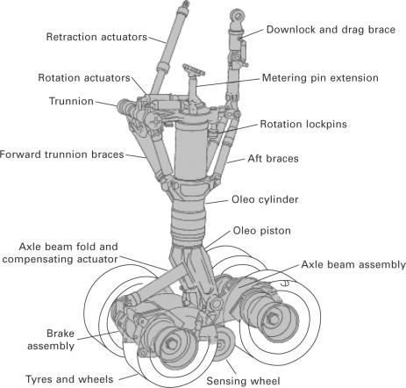

# fig.1. Components of Landing Gear

Adapted From-( Main-wheel bogie, from S. Pace, North American Valkyrie XB-70A, Aero Series vol. 30, Tab Books, 1984)

**External Models**

**Aircraft Model-** The aircraft Model needed to be prescribed mass not for the ground but also for the flying condition (i.e. 0 to 9.81*mass of plane).

**Tire Model-** The project is done by considering the tire as three parallel damper spring damper because in real life the tire are not linear spring.

**Bump Model-** The landing simulation is done on the basis fixed model from the library but to enforce a bump a original bump is required.

**Internal Loads**

**Shock Structure Model-** It is also known as piston- cylinder model in which we analysis the resisting force coming to piston through cylinder while piston is moving downward direction at the time of landing. We need to calculate that force

.

**Air Chamber Model-** It is the combination of hydraulic and pneumatic chamber to set the pre charge air pressure. In this there is no restriction is needed because both the chamber are mutually contacted

**Hydraulic Chamber Model-** It utilize the hydraulic chamber with the net correct piston area.

**Rebound Chamber Model-** In this chamber there are two valves which is use for to avoid cavitation in the chamber at the time of strut compression stroke.

**Landing Gear Design**

The modelling of landing gear is done on CATIA software. All the designs are done on the basis of various literature surveys and all dimension are in millimeter.

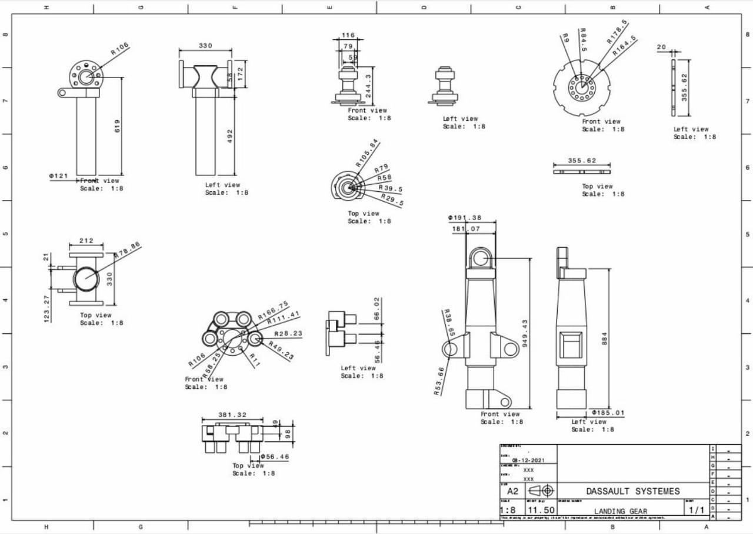

# Fig.2. Dimensions and Part of Landing Gear in 2D

**Material Selection**

Three type of materials are used for obtaining the best results. The three materials are:

STEEL ALLOY

ALUMINIUM ALLOY

TITANIUM ALLOY

These three are widely used in aerospace industries to make various sub systems and components. The four figures below shows the mechanical properties of these three alloys. In steel alloys, ferrium m54 turns out to be a good material to use but also ferrium s53 and aermet 100 were also tested. The results shows that these three are not so different in results but ferrium m54 is somewhat better than other two so ferium m54 was selected as steel alloy. In aluminium alloys, al 2040 is used as it is used in aerospace widely. In titanium alloys, ti 10-2-3 is used as it is better than ti 6Al-4V. So by this way ferrium s53, ti 10-2-3 and al 2040 were used to obtain results of deformation and stresses

**Table-1-Mateial Property**

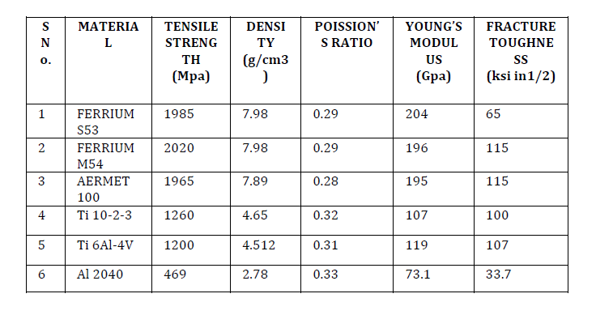



# 

**Geometry Creation**

In this process the landing gear geometry of assembly is created.



# 

# 

# Fig.3 Geometry of landing gear

# 

# Table-2- Landing Gear Geometry

# 

# 

**Meshing-** In this simulation landing gear surface is discrete with triangular mesh element.

# 

# 

# Fig.4. Meshing of Landing gear

# Table -2- Mesh model

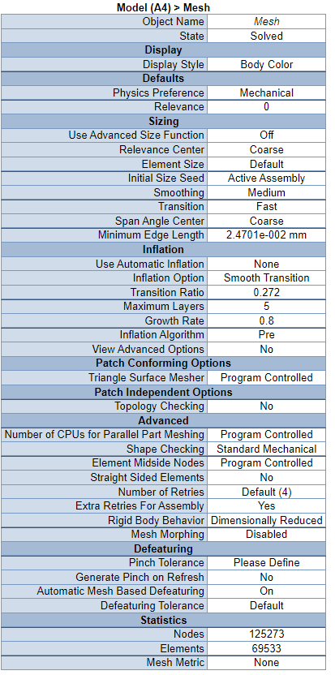

**Meshing continue**

**Aspect Ratio:-** The aspect ratio of the model is 1.196 (minimum) and maximum is 174.4.

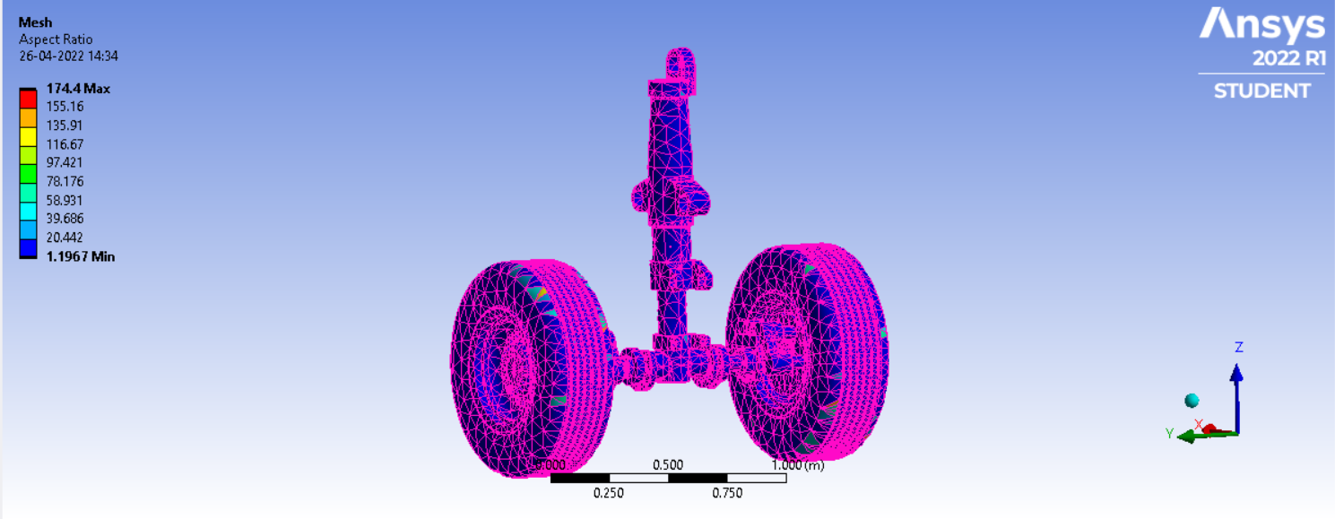

**Fig.5 Aspect Ratio**

**Jacobian ratio (MAPDL):-** The jacobian ratio of the model is 1 (minimum) and maximum is 39.999.

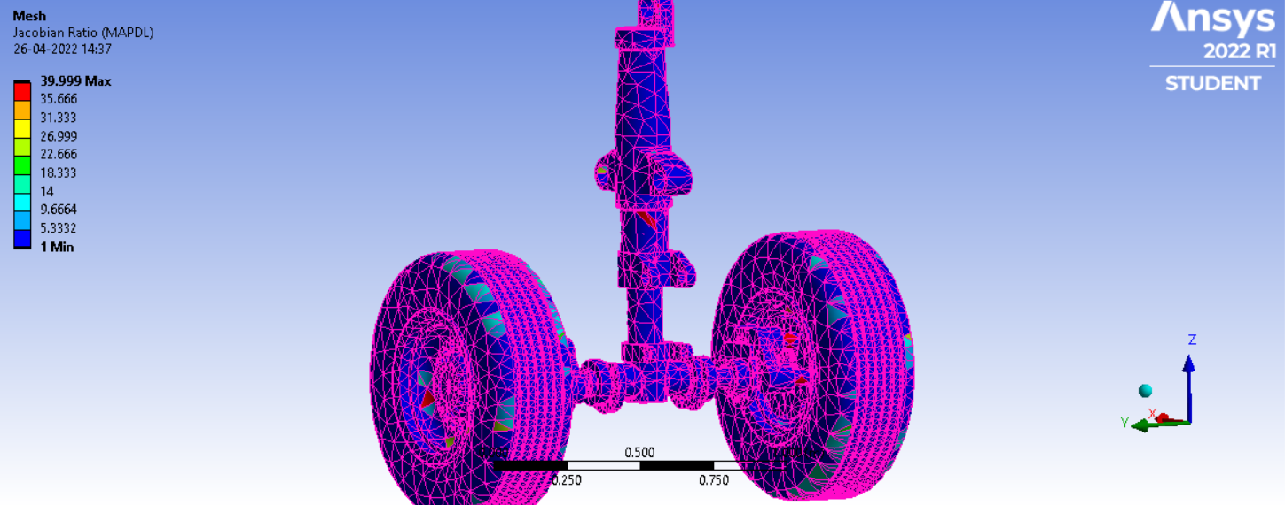

**Fig.6 Jacobian Ratio (MAPDL)**

**Jacobian ratio Node:-** The jacobian ratio of the model is 0.025 (minimum) and maximum is 1.

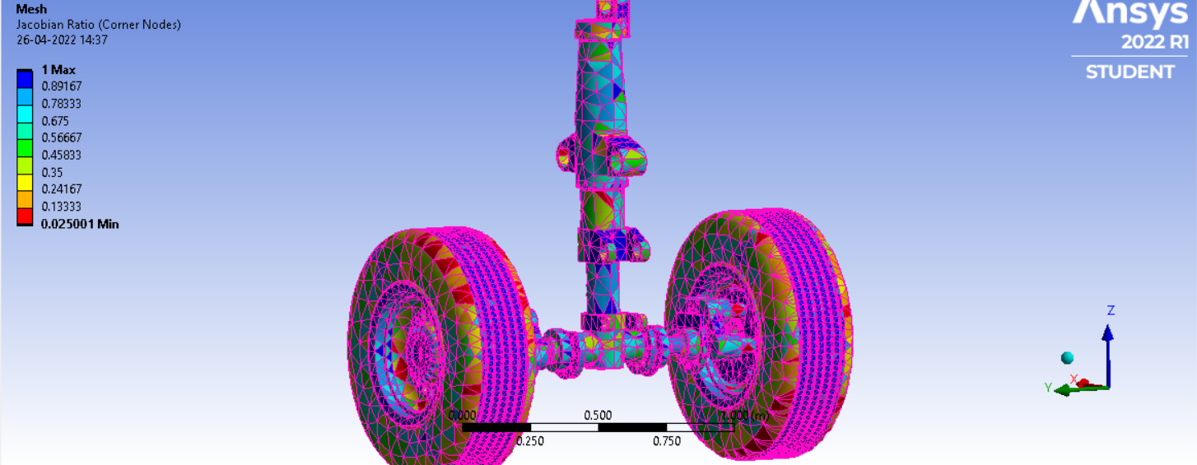

**Fig.7 jacobian Ratio Node**

**Element Quality:-** The element quality of the model is 0.0174 (minimum) and maximum is 0.999.

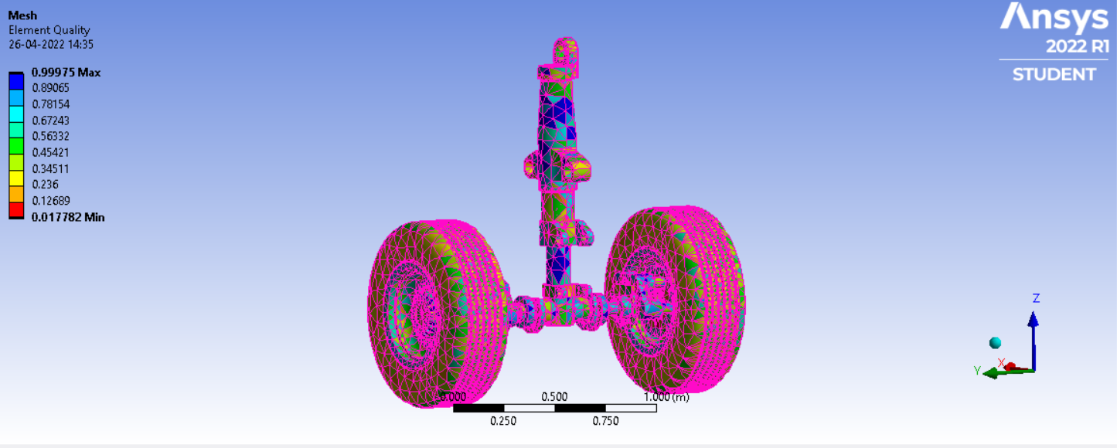

**Fig.8 Element Quality**

**EXPERIMENTAL RESULTS**

1. **Analysis of Titaninum Alloy ( Ti-10V-2FE-3Al )**

**a.Shear Stress Results of Titanium Alloy ( Ti-10V-2FE-3Al )**

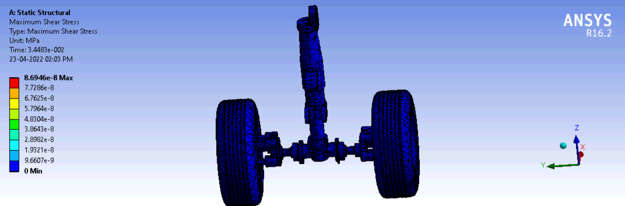

**Fig.9 .Shear Stress Analysis**

**b.Total Deformation Results of Titanium Alloy ( Ti-10V-2FE-3Al )**

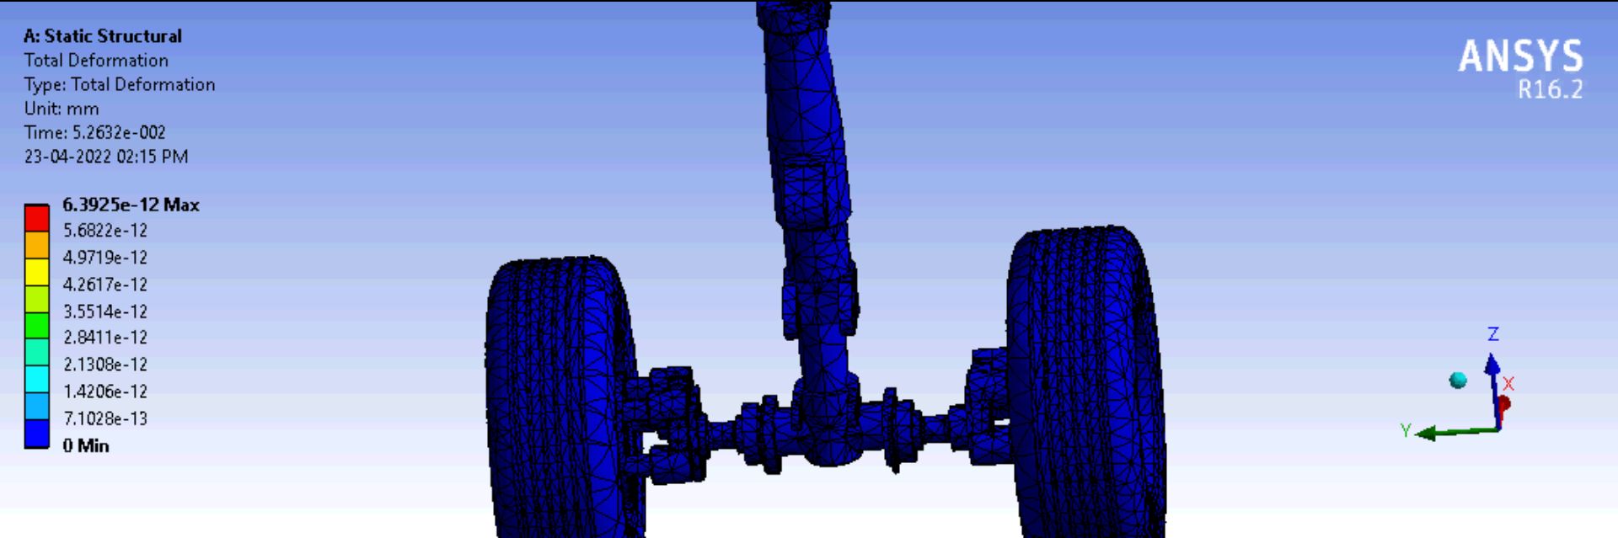

**Fig.10 .Total Deformation Analysis**

**c.Equivalent Elastic Strain Results of Titanium Alloy ( Ti-10V-2FE-3Al )**

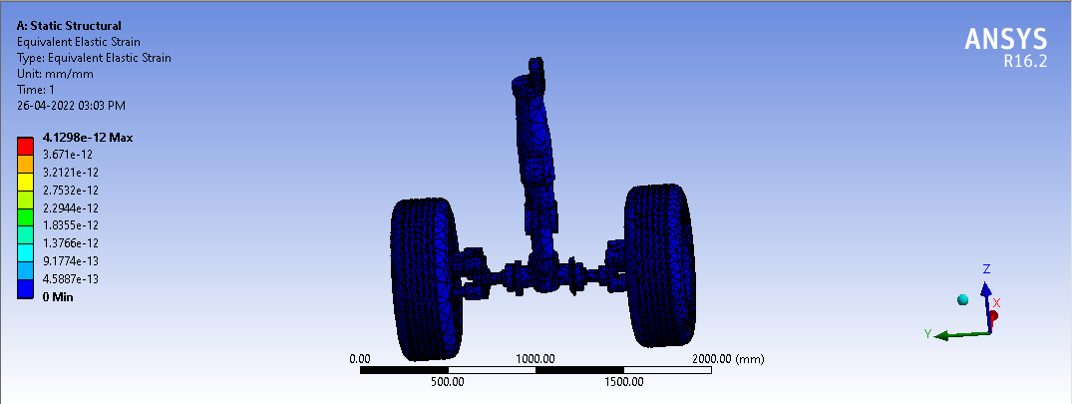

Fig.11. Equivalent Elastic Strain Analysis

**d.Equivalent (von-Mises) Stress Results of Titanium Alloy ( Ti-10V-2FE-3Al )**

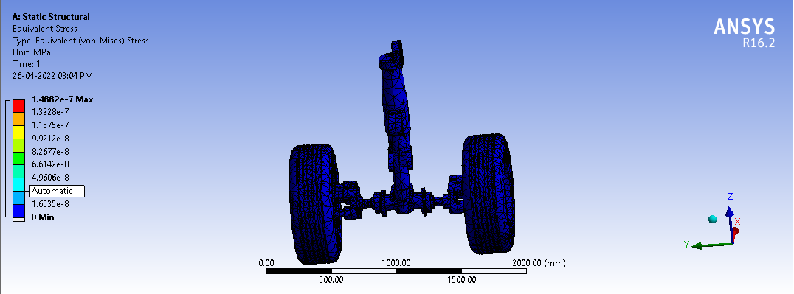

Fig.12. Equivalent (von-Mises) Stress Analysis

**e. Applied of force and fixed on landing gear wheel tyre and cylinder.** 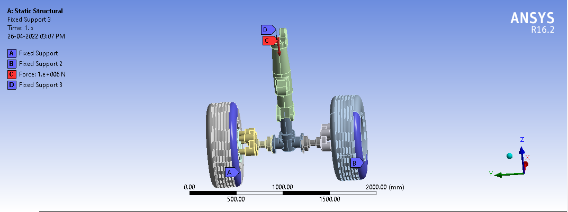

1. Analysis of Aluminium Alloy (Al 2040)

**a.Total deformation Results of Aluminium Alloy ( Al 2040 )**

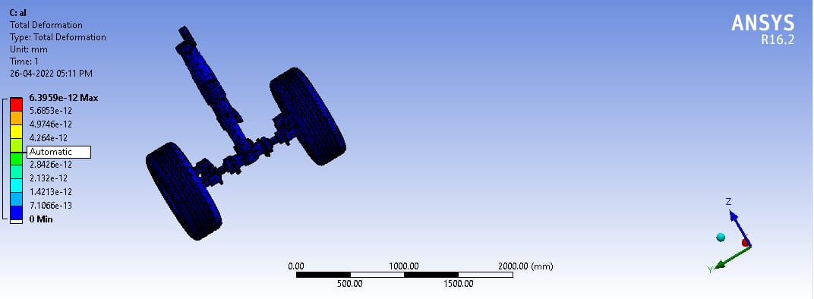

**Fig.13 Total deformation Analysis**

**b. Maximum shear stress Results of Aluminium Alloy ( Al 2040 )**

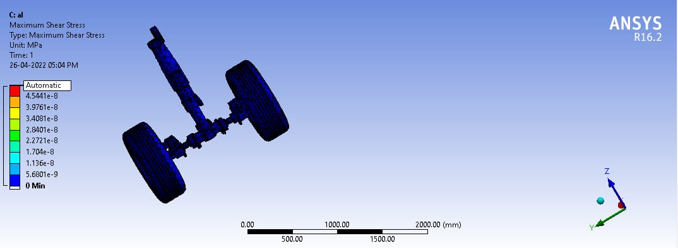

Fig.14 Maximum shear stress Analysis

**c. Equivalent (von-Mises) Stress Results of Aluminium Alloy ( Al 2040 )**

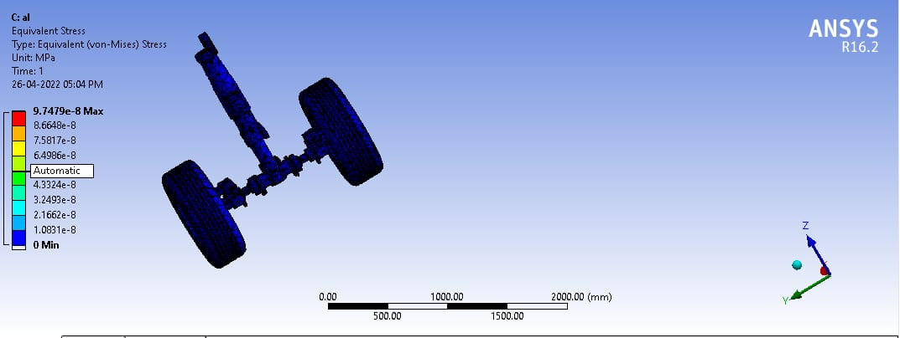

Fig.15. Equivalent (von-Mises) Stress Analysis

**d.Equivalent Elastic Strain Results of Aluminium Alloy ( Al 2040 )**

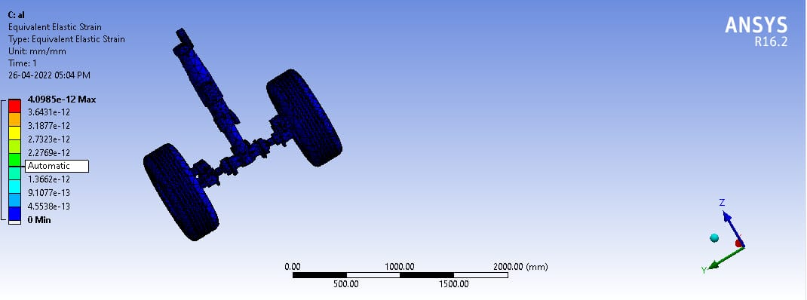Fig.16. Equivalent Elastic Strain Analysis

1. **Analysis of Titaninum Metal( Ti Metal)**

**a.Total deformation Results of Titanium Metal( Ti Metal)**

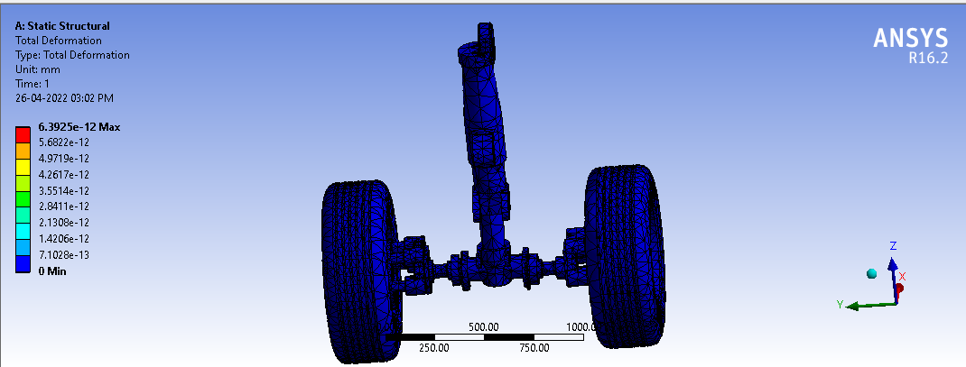

Fig.17 Total deformation Analysis

**b. Equivalent Elastic Strain Results of Titanium Metal( Ti Metal)**



Fig.18. Equivalent Elastic Strain Analysis

**c. Equivalent (von-Mises) Stress analysis Results of Titanium Metal( Ti Metal)**



Fig.19. Equivalent (von-Mises) Stress Analysis

**d. Maximum Shear Stress Results of Titanium Metal( Ti Metal)**

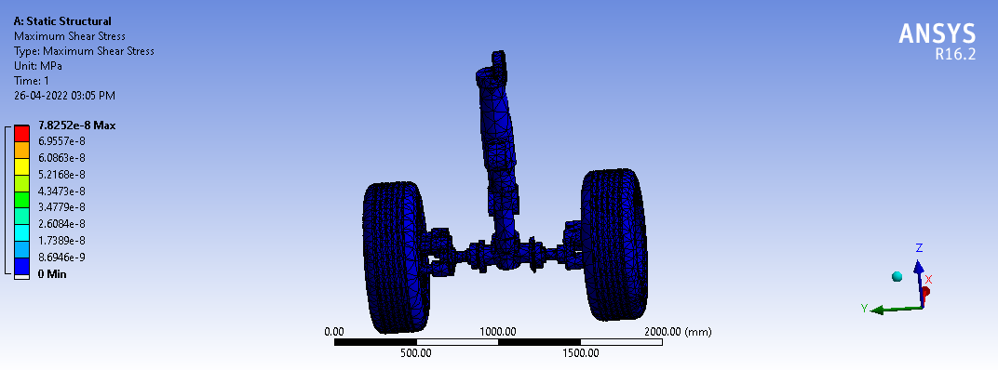

Fig.20. Maximum shear stress Analysis

**Observation Table**

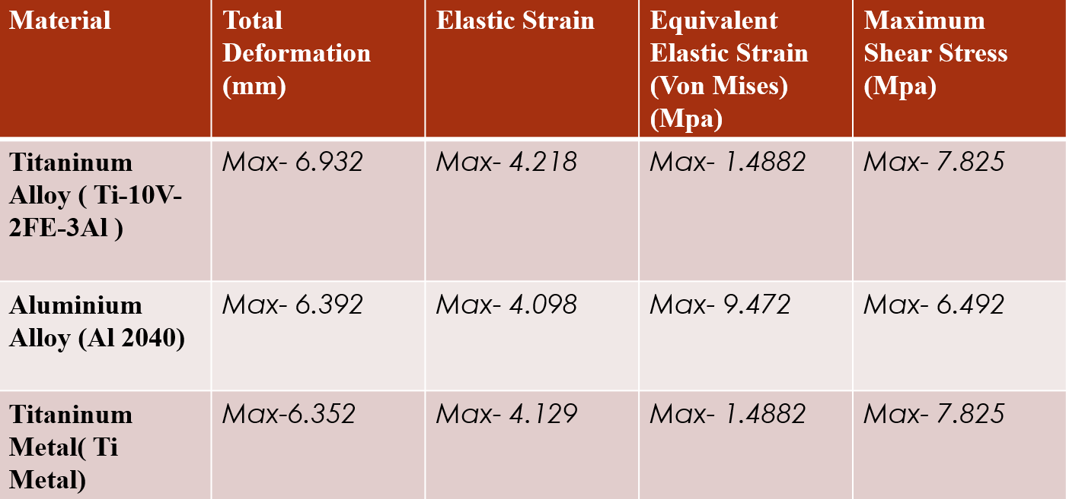

**Conclusion**

The landing gear is design and assembled in the CATIA software. The CAD model is considered to be structural analysis by finite element approach using the ANSYS package. The accuracy and precession depend on the mesh quality. Each component has been checked to see the better mesh quality to insecure the solution accuracy. After evaluating all the results and tables a conclusion is made that a single material should not be used for every component as the role of every component is different. So it is decided that the strut which is having the highest stress allocation should be made of steel alloy, as per results maximum stress is generated in steel alloy but the strut needs to be strong enough to handle all the loads so for strength steel alloy should be used, steel alloy is more is weight but for strength we have to compromise the weight in case of strut. For barrel again titanium alloy is selected as the highest deformation is seen their and a good stiff material is needed to reduce deformation though steel alloy has lesser deformation but steel alloy weights too much approx. 66% more so titanium alloy is selected. The upper and lower torsion links are having a good amount of stress and deformation on the area surrounding the small holes so titanium alloy should be used and wheel hub should be made of aluminum alloy. For nut and bolts though a stronger material is needed so steel alloy can be used for that application.

**FUTURE WORK**

1. Non-linear, fatigue and impact analysis can also be done to know the phenomenon of the landing gear.
2. Hydraulics and tires should be taken for best results.
3. Some other materials can also be tested.
4. Topology optimization can also be done to reduce the weight and a combination of reduced weight design and steel alloy can probably do the job and can be made in less cost.

**Reference**

1. Kuldip Ganorkar 1, Prof. Vishal Desh bhratar,Design optimization of Landing Gear of an Aircraft- A review, ISOR Journal of Mechanical and Civil engineering (ISOR-JMCE)e- ISSN:2278-1684,P-ISSN:2320-334X,PP 01 -04.
2. Aravind, Saravanan,Mohammed D Rijuvan Structural Analysis of the Landing Strut made up of carbon fibre composite material, International Jurnal of Mechanical and Production Engineering,ISSN: 2320-2092, Volume-1, issue-1 july-2013.
3. Janardhan B Hunusnale,C. Daksheeswara Reddy,Dr.P H V Sesha Talpa Sai, Fatigue Analysis of Piston Rod used in Aircraft Nose Landing Gear,International Journal and Magazine Of Engineering, Technology,Management And Research,ISSN No:2348- 4845,Volume No:2(2015),Issue No:7(July),page 1701-1708.
4. Prof. Ugo Galvanetto,Aerodynamic and Structural Design of Some Component of an Ultralight Aircraft, University of Padova,Department of Industrial Engineering, Thesis.
5. Mohammed Imran, Shabbir Ahmed R.M and Dr. Mohamed Haneef, 􀇲Static and dynamic response analysis for landing gear of test aircrafts􀇳, IJIRSET, vol. 3, issue 5, may 2014.
6. Rajesh A, Abhay B T, 􀇲Design and Analysis Aircraft Nose and Nose Landing Gear􀇳, IJES, vol.􀍶, issue 􀍳􀍲, pp 74-80, 2015.
7. Green W. L., Aircraft Hydraulic Systems: An Introduction to the Analysis of Systems and Components, Wiley, 1986 747_8

8. Project-Landing-Gear-Rapport-1-Final